# Student Version

| Section A – Program/Course details | | | |
| --- | --- | --- | --- |
| **Qualification code:** | ICT40120 | **Qualification title:** | Certificate IV in Information Technology (Programming) |
| **Subject Code:**  **Unit code:** | (CPRO5)  ICTWEB431  ICTWEB432  ICTWEB433  ICTWEB452 | **Subject Title:**  **Unit title:** | (Website Design Fundamentals)  Create and style simple markup language documents  Design website layouts  Confirm accessibility of websites  Create a markup language document |
| **Department name:** | BDIT, Computer and Information Technology | **CRN number:** | Enter CRN number |

| Section B – Assessment task details | | | |
| --- | --- | --- | --- |
| **Assessment number:** | 1 of 2 | **Semester/Year:** | 2/2022 |
| **Due date:** | Session 5 | **Duration of assessment:** | 5 hours |
| **Assessment method** | Observation | **Assessment task results** | Ungraded result (S/NS) |
| Other: Click here to enter text. |

| Section C – Instructions to students |
| --- |
| **Task instructions:** |
| This assessment is comprised of 5 parts. You are required to complete all 5 parts under direct observation of your assessor. You assessor will schedule a session for the assessment, and you must attend the session to be assessed.  Part 1. Setup development environment and prepare resources Part 2. Design & develop a header  Part 3. Design & develop an image gallery  Part 4. Design & develop a web form  Part 5. Design & develop an article style  See the supporting documentation section in this document for further instructions.  For all parts in this assessment   * You are required to correctly answer all questions and complete all tasks as per instructions and assessment criteria to a satisfactory level for each question/task of this assessment to be given a satisfactory result by the assessor. * Once you have completed all the questions, the assessment must be uploaded and submitted along with the signed assessment coversheet via Brightspace. * If the result is not satisfactory within the enrolment period as per Holmesglen assessment procedure, you will be requested to resubmit within seven days of receiving feedback. You are permitted two resubmissions per assessment task. * You must contribute to and abide by organisational standards including intellectual property and privacy laws. * You may use the internet for research purpose however the learner’s answer must be in their own words. * See supporting documentation for further instructions |

| Section D – Conditions for assessment | |
| --- | --- |
| **Conditions:**  Student to complete and attach Assessment Submission Cover Sheet to the completed Assessment Task. | |
| * This assessment is to be completed individually. * You must meet all criteria listed in the marking guide to be satisfactory in this task. * You may resubmit this task if not successful within the enrolment period as per Holmesglen conducting assessment procedure. * This is an individual task; however, you are required to get information, feedback and ideas from your assessor, peers and industry to help complete the assessment planning guide. * It is expected all documents will be completed and submitted electronically but if this is not possible, make alternative arrangements for submitting the documents with your assessor. * You will have the opportunity to resubmit if any part of the assessment is deemed unsatisfactory * You will be permitted TWO (2) resubmissions per assessment task * You can appeal an assessment decision according to the Holmesglen Assessment Complaints and Appeals Procedure. * If you feel you require special allowance or adjustment to this task, please decide with your assessor within one week of commencing this assessment. * You may use the internet for research purpose only. | |
| **Equipment/resources students must supply:** | **Equipment/resources to be provided by the RTO:** |
| Students intending to learn remotely will require access to: A PC/laptop with the following minimum specification:   * Quad Core CPU * 8GB of RAM * CPU with minimum 2ghz processor or faster * 200GB of Storage * Access to internet connection (ADSL or cable connection desirable) * Headset with microphone & webcam   Access to Applications:   * Office 365 (including Word, Excel, PowerPoint…) – free to download through office.com login with your Holmesglen email * WebEx - free to download * 7Zip or an equivalent compression utility - free to download * OneDrive or google drive account for storage * Visual Studio Code * 2 web browsers (e.g Google Chrome + Edge) | A Mac or PC/laptop with the following minimum specification:   * 8GB of RAM * CPU with minimum 2ghz processor or faster * 200GB of Storage * Monitor 24" (PC only, dual monitor optional but preferred) * Headset with microphone (webcam optional but preferred) * Access to internet connection (ADSL or cable connection desirable)   Applications:   * Office 365 (including Word, Excel, PowerPoint…) * WebEx * 7Zip * OneDrive * Web browsers * Visual Studio Code |

|  |  |  |  |
| --- | --- | --- | --- |
| Section E – Marking Sheet - Student Answer Sheet | | | |
| **Subject code:**  **Unit code:** | (CPRO5)  ICTWEB431  ICTWEB432  ICTWEB433  ICTWEB452 | **Subject Title:**  **Unit title:** | (Website Design Fundamentals)  Create and style simple markup language documents  Design website layouts  Confirm accessibility of websites  Create a markup language document |

**Assessment Submission Cover Sheet (VET)**

|  |  |
| --- | --- |
| **Student Declaration – Must be signed before submission** |  |
| By submitting this assessment task and signing the below, I acknowledge and agree that:  • This completed assessment task is my own work.  • I understand the serious nature of plagiarism and I am aware of the penalties that exist for breaching this.  • I have kept a copy of this assessment task.  • The assessor may provide a copy of this assessment task to another member of the Institute for validation and/or benchmarking purposes. | |

|  |  |  |  |
| --- | --- | --- | --- |
| **Student ID:** | **100660526** | **Student name:** | **Yanan Wu** |

|  |  |
| --- | --- |
| **Submission or observation date:** |  |
| **Student signature**  For electronic submissions: By typing your name in the student signature field, you are accepting the above declaration. | **Yanan Wu** |

| Section F – Feedback to Student | | | | | | |
| --- | --- | --- | --- | --- | --- | --- |
| **Has the student successfully completed this assessment task?** | | | | | **Yes** | **No** |
|  |  |
| **Additional Assessor comments (as appropriate):** | | | | | | |
|  | | | | | | |
| **Resubmission allowed:** | **Yes** | **No** | **Resubmission due date:** |  | | |
| **Assessor name:** |  | | | | | |
| **Assessor signature:** |  | | | | | |
| **Date assessed:** |  | | | | | |

# Supporting document

# Develop Web Page Components

|  |  |  |  |
| --- | --- | --- | --- |
| **Subject code:**  **Unit code**: | (CPRO5)  ICTWEB431  ICTWEB432  ICTWEB433  ICTWEB452 | **Subject title:**  **Unit title:** | (Website Design Fundamentals)  Create and style simple markup language documents  Design website layouts  Confirm accessibility of websites  Create a markup language document |

You are required to develop several user interface components for a web page, including

* A header, including a logo and navigation bar
* An image gallery
* A web form
* An article template

You will find the detailed requirements in each part below.

During the development, sample texts and images are required using placeholders. You could get the resources using any online placeholder generator tools to create dummy texts and images. Such as

* Use Lorem Ipsum tool (<https://www.lipsum.com/>) to generate dummy texts
* Use Dummy Image tool (<https://dummyimage.com/>) to generate dummy images

You are required to follow the coding guideline below for all HTML and CSS codes

<https://www.w3schools.com/html/html5_syntax.asp>

You are required to develop test plan and document test results using a provided templat.

All the tasks must be done in the class under the direct observation of an assessor.

## Part 1. Setup development environment and prepare resources

Before you get started into programming, please setup a development environment and prepare resources required for the work. Refer the check list below

|  |  |
| --- | --- |
| **Check List** | |
| A code editor, such as Visual Studio Code |  |
| Two different web browsers, such as Google Chrome + MS Edge |  |
| Internet connection |  |
| Coding guidelines for HTML and CSS |  |
| Test plan template |  |
| Dummy texts and images generator |  |
| Word processing software |  |

## Part 2. Design & develop the header UI

You are required to design and develop a header section for a website. Below is the graphic design and detailed requirements.

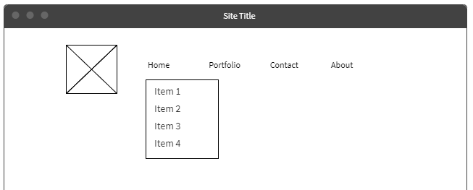

Requirements

* Font family – “Verdana, sans-serif”, font size – “14px”, font color – “black”
* Coding standards shall be followed then writing HTML and CSS code.
* CSS code shall be written in a separate CSS file.
* Test cases shall be developed according to the requirements and using the provided template.
* Web component shall be tested according to the test cases, and a test report shall be generated.
* Web component shall be tested in at least two different web browsers.

You need to follow the steps below to complete this part.

Step 1 – Review and confirm client requirements

Step 2 – Develop test cases in test plan

Step 3 – Develop the HTML code

Step 4 – Develop the CSS code

Step 5 – Conduct test according to test plan and record result

Step 6 – Identify gaps between requirements and document and apply changes as required

Step 7 – Present the results to client and obtain sign-off

Client Name: ____________________

Client Signature: ____________________

Date: ____________________

Assessor’s Comments

|  |
| --- |
|  |

## Part 3. Design & develop an image gallery

You are required to design and develop an image gallery section for a website. Below is the graphic design and detailed requirements.

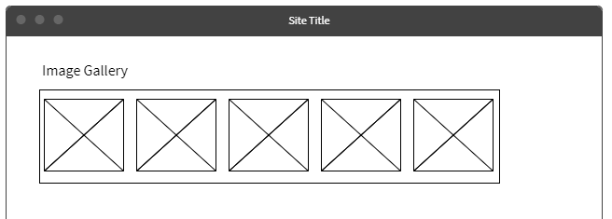

Requirements

* Font family – “Verdana, sans-serif”, font size – “18px”, font color – “black”
* Coding standards shall be followed then writing HTML and CSS code.
* CSS code shall be written in a separate CSS file.
* Test cases shall be developed according to the requirements and using the provided template.
* Web component shall be tested according to the test cases, and a test report shall be generated.
* Web component shall be tested in at least two different web browsers.

You need to follow the steps below to complete this part.

Step 1 – Review and confirm client requirements

Step 2 – Develop test cases in test plan

Step 3 – Develop the HTML code

Step 4 – Develop the CSS code

Step 5 – Conduct test according to test plan and record result

Step 6 – Identify gaps between requirements and document and apply changes as required

Step 7 – Present the results to client and obtain sign-off

Client Name: ____________________

Client Signature: ____________________

Date: ____________________

Assessor’s Comments

|  |
| --- |
|  |

## Part 4. Design & develop a web form

You are required to design and develop a web form section for a website. Below is the graphic design and detailed requirements.

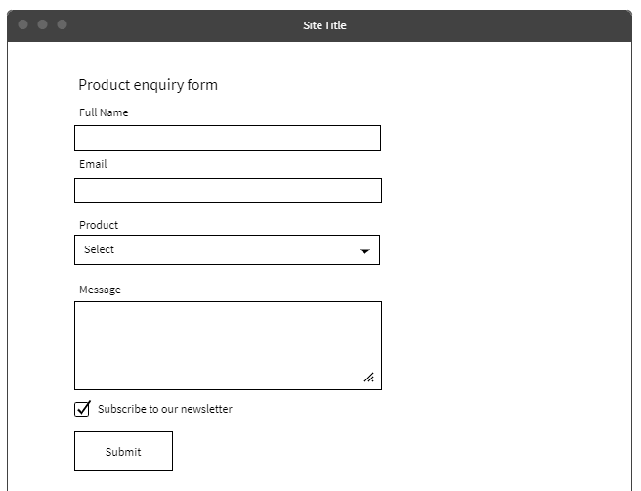

Requirements

* Font family – “Verdana, sans-serif”, font size – “18px” for the words “Product enquiry form”; “14px” for everything else, font color – “black”
* Coding standards shall be followed then writing HTML and CSS code.
* CSS code shall be written in a separate CSS file.
* Test cases shall be developed according to the requirements and using the provided template.
* Web component shall be tested according to the test cases, and a test report shall be generated.
* Web component shall be tested in at least two different web browsers.

You need to follow the steps below to complete this part.

Step 1 – Review and confirm client requirements

Step 2 – Develop test cases in test plan

Step 3 – Develop the HTML code

Step 4 – Develop the CSS code

Step 5 – Conduct test according to test plan and record result

Step 6 – Identify gaps between requirements and document and apply changes as required

Step 7 – Present the results to client and obtain sign-off

Client Name: ____________________

Client Signature: ____________________

Date: ____________________

Assessor’s Comments

|  |
| --- |
|  |

## Part 5. Design & develop an article style

You are required to design and develop an article style section for a website. Below is the graphic design and detailed requirements.

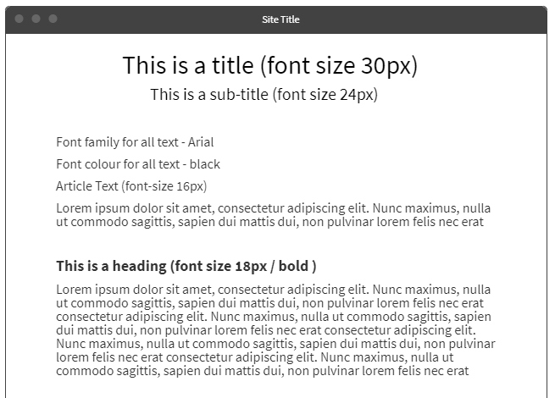

Requirements

* The required font family, font size, font color information of the web component can be found in the graphic design above.
* Coding standards shall be followed then writing HTML and CSS code.
* CSS code shall be written in a separate CSS file.
* Test cases shall be developed according to the requirements and using the provided template.
* Web component shall be tested according to the test cases, and a test report shall be generated.
* Web component shall be tested in at least two different web browsers.

You need to follow the steps below to complete this part.

Step 1 – Review and confirm client requirements

Step 2 – Develop test cases in test plan

Step 3 – Develop the HTML code

Step 4 – Develop the CSS code

Step 5 – Conduct test according to test plan and record result

Step 6 – Identify gaps between requirements and document and apply changes as required

Step 7 – Present the results to client and obtain sign-off

Client Name: ____________________

Client Signature: ____________________

Date: ____________________

Assessor’s Comments

|  |
| --- |
|  |

## Final submission check list

Please make sure the following documents are all finished before submitting for final review.

|  |  |
| --- | --- |
| **Check List** | |
| Test plan document |  |
| Test result document |  |
| All source codes |  |
| Assessment document with client signature for all tasks |  |
| Signed coversheet |  |

When all above documents are ready for final review, please create a zip file with all above document included and submit to learning management system.